## PROSIT 2

KEYWORDS

1. Database management systems (DBMS) -a software system that enables users to define, create, manage, and interact with databases. It provides data storage, retrieval, and organization mechanisms while ensuring data integrity and security.
2. IT Infrastructures infrastructure encompasses all the hardware, software, networks, and services necessary for delivering IT operations and solutions.
3. Slow response times -This refers to delays experienced when accessing or processing data within a system, often caused by limited computing resources or poorly optimized software
4. Data loss -Data loss occurs when data is accidentally deleted, corrupted, or becomes inaccessible due to hardware failures, cyberattacks, or inadequate backup strategies.
5. Cloud computing -Cloud computing is a technology that provides on-demand access to computing resources such as servers, storage, and applications over the internet.
6. SaaS -is a cloud computing model where software applications are hosted and managed by a provider and accessed via the internet. Users do not have to install or maintain software locally, as the service provider handles updates, security, and infrastructure. Examples include Google Workspace, Salesforce, and Dropbox.
7. PaaS -is a cloud computing model that provides a platform for developers to build, test, deploy, and manage applications without managing the underlying infrastructure. It includes tools and services such as operating systems, databases, and development frameworks. Examples of PaaS providers include Microsoft Azure and AWS Elastic Beanstalk
8. IaaS -is a cloud computing model that provides virtualized computing resources, such as servers, storage, and networking, on a pay-as-you-go basis. Unlike PaaS and SaaS, IaaS gives users greater control over the underlying infrastructure. Providers like AWS, Google Cloud, and Microsoft Azure offer IaaS solutions.
9. migrating data management systems to the cloud-This involves transitioning from on-premises database systems to cloud-based platforms. Migration to the cloud offers benefits such as scalability, improved performance, and enhanced data security. However, it requires detailed planning to minimize risks, such as data loss or downtime.
10. Data security -refers to protecting data from unauthorized access, breaches, and corruption. It involves implementing encryption, secure access controls, backup strategies, and compliance with privacy regulations.
11. Current Operations -refer to the ongoing processes, systems, and activities that are essential for running a business. These include day-to-day transactions, data processing, and customer services.
12. Change management -is the systematic approach to transitioning individuals, teams, and organizations from a current state to a desired future state. It involves planning, communication, training, and support to minimize resistance and ensure the adoption of new systems.
13. System performance -measures how efficiently and effectively an IT system executes tasks. Key aspects include speed, reliability, and resource utilization.

**CONTEXT**

TechNova faces data management challenges due to outdated systems, affecting scalability and performance. Maya, a data expert, proposes migrating to cloud computing to enhance flexibility and growth.

**PROBLEM STATEMENT**

How can TechNova successfully transition to a cloud-based data management system that ensures scalability, performance, and security while minimizing operational disruptions and maintaining customer trust?

**CONSTRAINTS :**

* Scalable
* Secure
* Flexible
* Does not disrupt current operations

**DELIVERABLES :**

* Compare different cloud computing models
* Detailed cloud migration plan

**SOLUTION APPROACH**

* Use IaaS, SaaS, PaaS or combination
* Have a hybrid cloud
* Data encryptions (general)
* Access control
* Server maintenance (avoid current Operations)
* Operation Scheduling
* Compliance audit
* Cloud providers

**ACTION PLAN**

Study & compare cloud models (scalability + flexibility)

* Cloud computing is broadly categorized into three primary service models: **IaaS (Infrastructure as a Service)**, **PaaS (Platform as a Service)**, and **SaaS (Software as a Service)**. These service models define how organizations use the cloud and the extent of management required in their environments. Additionally, with the growing popularity of **containers** and **microservices architectures**, a new category called **CaaS (Containers as a Service)** has emerged.
* The term "as a service" refers to offerings provided by a third-party provider over the cloud. Instead of maintaining physical hardware or software in an on-premises data center, businesses pay for what they need on a subscription or consumption basis. This approach eliminates the need for organizations to manage infrastructure, enabling them to access resources on demand over the internet.

## IaaS (Infrastructure as a Service)

* IaaS delivers on-demand access to infrastructure resources such as **compute power**, **storage**, **networking**, and **virtualization**. It allows organizations to bypass the costs and complexities of managing their own physical data centers. Instead, they gain access to a scalable and flexible infrastructure managed by the cloud provider.
* However, with IaaS, customers are still responsible for managing the **operating systems**, **middleware**, **virtual machines (VMs)**, and the applications they run. This model provides maximum control and is highly suited for businesses with custom applications, legacy systems, or unpredictable workloads. Common examples of IaaS include services like **AWS EC2**, **Microsoft Azure Virtual Machines**, and **Google Compute Engine**.

## CaaS (Containers as a Service)

* CaaS is a relatively new cloud service model that focuses on supporting **containerized applications**. It provides a managed environment for deploying, running, and managing containers without requiring businesses to build or maintain the underlying infrastructure. CaaS is often viewed as an extension of IaaS, as it replaces VMs with **containers** as the primary resource.
* This service is particularly advantageous for organizations leveraging **microservices architectures**, as it enables developers to package applications and their dependencies into portable units. While the environment is managed by the cloud provider, customers remain responsible for writing the code and managing their applications. Examples of CaaS platforms include **Kubernetes**, **Docker Swarm**, and **Red Hat OpenShift**.

## PaaS (Platform as a Service)

* PaaS provides a comprehensive platform for **developing, testing, and deploying applications**. This model abstracts the complexities of infrastructure management, enabling developers to focus solely on coding and building their applications. The cloud provider manages all the underlying hardware, operating systems, and middleware, while users retain responsibility for their applications and data.
* PaaS is ideal for organizations aiming to accelerate development cycles without worrying about infrastructure setup. It offers a seamless way to integrate tools, APIs, and frameworks, allowing teams to build modern applications efficiently. Examples of PaaS include **Google App Engine**, **Heroku**, and **Microsoft Azure App Services**.

## SaaS (Software as a Service)

* SaaS delivers **fully managed applications** through the cloud. These services are ready-to-use and require no infrastructure setup or maintenance by the customer. Updates, bug fixes, and performance optimizations are handled entirely by the service provider, allowing users to focus on utilizing the software for their needs.
* SaaS applications are typically accessed through a web browser, eliminating the need for installations or complex configurations. They are especially beneficial for organizations requiring scalable, out-of-the-box solutions like **CRM tools (e.g., Salesforce)**, **productivity suites (e.g., Google Workspace)**, or **ERP systems (e.g., SAP Cloud)**.

|  |  |  |
| --- | --- | --- |

|  |  |  |
| --- | --- | --- |
| **Model** | **Scalability** | **Flexibility** |
| **Infrastructure as a Service** | High scalability: Users can easily scale resources like compute power, storage, and networking up or down based on demand. | Maximum flexibility: Full control over the infrastructure, including operating systems, virtual machines, and middleware |
| **Platform as a Service** | High scalability: Automatically scales platforms and tools to support application development and deployment. | Moderate flexibility: Limited control over the underlying infrastructure, but full control over applications and data |
| **Software as a Service** | High scalability: Seamless scalability of the application as user demand increases | Low flexibility: Users can only configure and customize within the constraints of the application. No access to underlying infrastructure |
| **Containers as a Service** | High scalability: Supports scaling of containerized applications across multiple environments. Ideal for microservices | High flexibility: Allows control over containers while the cloud provider manages the infrastructure. Great for developers and IT teams |

* **Green**: highlight the highest advantage (excellent scalability/flexibility).
* **Yellow**: indicate moderate capability (balanced scalability/flexibility).
* **Red**: show the lowest capability (restricted scalability/flexibility).
* 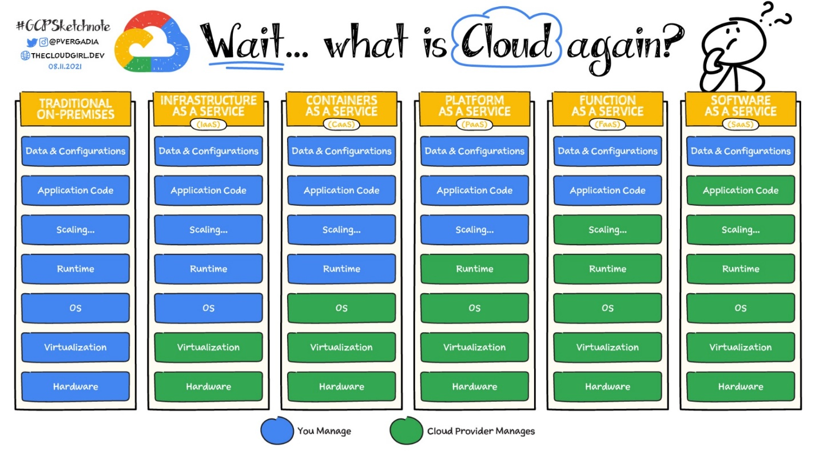

Explore different ways to ensure data security in the cloud

* **Adopt a Zero Trust Security Model:** 🛡️

Implement a Zero Trust framework, where no entity inside or outside the network is trusted by default. Verify every access request as if it originates from an open network, ensuring strict access controls and authentication.

[Okta](https://www.linkedin.com/company/okta-inc-/) Identity Cloud is favored for its comprehensive approach to identity and access management, embodying the Zero Trust model by verifying every user and device, making it a pivotal solution for modern security challenges.

* **2. Encrypt Data at Rest and in Transit:** 🔏

Protect your data comprehensively by encrypting it both at rest and in transit. Utilize advanced encryption standards to secure sensitive information, making it unreadable to unauthorized individuals.

[veracrypt](https://www.linkedin.com/company/veracrypt/) is renowned for its strong encryption capabilities, providing robust security measures for data at rest and in transit, making it an essential tool for protecting sensitive information.

* **3. Implement Multi-Factor Authentication (MFA):** 🚀

Strengthen access controls with Multi-Factor Authentication, requiring users to provide two or more verification factors to gain access to cloud resources, significantly reducing the risk of unauthorized access.

[Duo Security](https://www.linkedin.com/company/duosec/) is highly regarded for its user-friendly MFA solutions that add an essential layer of security, significantly mitigating the risk of unauthorized access through compromised credentials.

* **4. Regularly Update and Patch Systems**: 🛠️

Keep your cloud infrastructure secure by regularly updating and patching operating systems, applications, and security tools to protect against vulnerabilities and exploits.

[ManageEngine](https://www.linkedin.com/company/manageengine/) Patch Manager Plus automates the patch management process, ensuring systems are always up to date and protected against vulnerabilities, making it a key asset in maintaining cloud security.

* **5. Conduct Regular Security Audits and Compliance Checks:** 📋

Proactively identify and remediate security gaps by conducting thorough audits and compliance checks. Ensure your cloud environment adheres to industry standards and regulations to maintain data integrity and privacy.

[Nessus Technology](https://www.linkedin.com/company/nessus-technology/) stands out for its extensive vulnerability scanning capabilities, offering detailed insights that help organizations identify and remediate security gaps efficiently, thus maintaining compliance and security standards.

* **6. Utilize Cloud Access Security Brokers (CASBs):** 🕵️♂️

Employ Cloud Access Security Brokers to enforce security policies across your cloud environment. CASBs provide visibility, compliance, data security, and threat protection capabilities to enhance overall security posture.

[McAfee MVISION](https://www.linkedin.com/company/mcafee-mvision/) Cloud provides comprehensive visibility and control over cloud services, making it an indispensable tool for enforcing security policies and protecting against threats in cloud environments.

* **7. Leverage Advanced Threat Detection and Response:** 🚨

Implement advanced threat detection tools and services to monitor for suspicious activities and respond to threats in real-time. Utilize machine learning and AI to detect and mitigate sophisticated attacks.

[Splunk](https://www.linkedin.com/company/splunk/) Enterprise is chosen for its powerful data analytics and security insights, enabling organizations to detect and respond to advanced threats swiftly, ensuring a proactive security posture.

* **8. Ensure Data Backups and Disaster Recovery Plans:** 💾

Regularly back up data and have a robust disaster recovery plan in place to ensure business continuity in the event of data loss, cyberattacks, or system failures.

[Veeam Backup and Disaster Recovery](https://www.linkedin.com/showcase/veeam-backup-and-disaster-recovery/) is celebrated for its reliability and versatility in data protection, offering robust backup and disaster recovery solutions that ensure business continuity and resilience.

* **9. Secure APIs and Endpoints:** 🔒

Ensure the security of APIs and endpoints that interact with your cloud services. Adopt rigorous authentication, encryption, and monitoring practices to protect against unauthorized access and data breaches.

[Postman](https://www.linkedin.com/company/postman-platform/) is favored for API security, offering a comprehensive set of tools for developing, testing, and securing APIs, thus ensuring they are protected against unauthorized access and breaches.

* **10. Foster a Culture of Security Awareness:** 🌟

Cultivate a security-conscious culture within your organization. Provide ongoing training and resources to employees on best practices for cloud data security and the importance of vigilance in protecting sensitive information.

[KnowBe4](https://www.linkedin.com/company/knowbe4/) is the leading platform for security awareness training, providing engaging content and simulations that educate employees on security best practices, making it a cornerstone in building a security-conscious culture.

Study about public, private & hybrid clouds

### Public Cloud

**Pros:**

- Scalability: Public clouds provide virtually unlimited resources that can be scaled up or down quickly based on demand, making them ideal for businesses with fluctuating workloads.

- Cost Efficiency: Users pay only for the resources they consume, eliminating the need for significant upfront investments in hardware and infrastructure.

- Rapid Deployment: Resources can be provisioned quickly, allowing businesses to launch applications and services faster.

**Cons:**

- Security Concerns: Storing sensitive data on third-party servers raises concerns about data privacy and compliance with regulations.

- Vendor Lock-In: Businesses may face challenges if they want to switch providers due to proprietary technologies used by cloud vendors.

- Limited Customization: Public cloud services may not offer the level of customization that some businesses require for specific applications.

### Private Cloud

**Pros:**

- Enhanced Security: Private clouds provide a dedicated environment, offering greater control over data security and compliance measures.

- Customization: Organizations can tailor their infrastructure to meet specific needs, optimizing performance for particular applications.

- Predictable Performance: Resources are dedicated to a single organization, which can lead to more consistent performance compared to shared environments.

**Cons:**

- Higher Costs: The need for dedicated hardware and maintenance can lead to higher operational costs compared to public clouds.

- Limited Scalability: Scaling requires additional investments in hardware, which may not be as flexible as public cloud options.

- Longer Deployment Times: Setting up a private cloud can take longer due to the need for infrastructure setup and configuration.

### Hybrid Cloud

**Pros:**

- Flexibility: Organizations can use both public and private clouds, allowing them to keep sensitive data secure while leveraging the scalability of public clouds for less critical workloads.

- Cost Optimization: Businesses can optimize costs by running workloads in the most cost-effective environment based on current needs.

- Improved Disaster Recovery: Hybrid solutions can enhance resilience by using public cloud resources for backup and disaster recovery while keeping primary operations on-premises.

**Cons:**

- Complex Management: Managing multiple environments can complicate IT operations and require more sophisticated management tools.

- Integration Challenges: Ensuring seamless integration between public and private components can be technically challenging and resource-intensive.

- Potential Latency Issues: Data transfer between public and private clouds may introduce latency that could affect application performance.

### Multi-Cloud

**Pros:**

- Avoiding Vendor Lock-In: Using multiple cloud providers allows organizations to avoid dependency on a single vendor, enhancing flexibility and bargaining power.

- Optimized Workloads: Organizations can choose the best provider for each workload based on performance, cost, or specific features.

- Increased Resilience: Distributing workloads across multiple clouds enhances availability and disaster recovery capabilities, reducing the risk of downtime.

**Cons:**

- Management Complexity: Coordinating multiple cloud environments can increase operational complexity and require advanced management strategies.

- Interoperability Issues: Different cloud providers may use different technologies, leading to challenges in ensuring compatibility between services.

- Higher Costs Potentially: While it offers flexibility, managing multiple contracts and services can lead to increased administrative costs if not managed properly.

Conclusion

Each cloud computing model presents distinct advantages and disadvantages related to scalability, flexibility, cost management, security, and operational complexity. Organizations should carefully evaluate their specific needs, regulatory requirements, and growth projections when choosing a cloud strategy. Adopting a hybrid or multi-cloud approach often provides a balanced solution that leverages the strengths of various models while mitigating their weaknesses.

Compare cloud providers & choose the one that abides by all constraints

* A cloud service provider rents out the combination of technology, infrastructure, and expertise to other companies and individuals for cloud computing, including online storage, computing, and networking over the Internet.
* Cloud service providers own and operate multiple data centers worldwide that house the physical infrastructure required for cloud computing. These include servers, hard drives, and cooling systems.
* Anyone, anywhere, and at any time can access this cloud infrastructure by connecting to these data centers and purchasing as much capacity as they require on a pay-as-you-go basis (usage-based pricing).

Benefits of using CSPs (Cloud Service Providers):

* Low capital outlay – Customers do not incur large capital expenditures (CAPEX) on infrastructure, but instead pay a low, ongoing fee for their usage.
* Faster time-to-market – By not purchasing, installing, testing, and optimizing cloud infrastructure, businesses can produce their products and services much more quickly
* Agility – CSPs enable cloud-based brands to pivot faster since they do not need to sell existing infrastructure and purchase updated ones every time they want to explore new markets or lines of business.
* Cloud computing services – CSPs deliver Infrastructure-as-a-Service (IaaS), Platform-as-a-Service (PaaS), Software-as-a-Service (SaaS), and Serverless Computing
* Optimal cloud delivery models – Businesses can choose between public, private, hybrid, and multi-cloud cloud services from cloud service providers.
* Pay-as-you-go pricing – You pay only for the capacity of cloud resources you use. No provisioning, upfront payments, or long-term contracts are required either.
* Managed services – A CSP grants various degrees of control over the infrastructure they rent out. This infrastructure can be fully managed by your CSP or largely configured by your engineers.
* Disaster recovery – A CSP can backup your data in multiple regions across the world, which you can retrieve in case of a data center failure in one region or your on-premises system.

Challenges of CSPs:

* Data confidentiality - The public cloud depends on a network of third-party owned, shared, and remote servers to process, store, and manage data.
* Data security - hackers can infiltrate their systems and compromise customer data, resulting in reputational damage, losing customers, and lawsuits.
* Infrastructure control limitations - To optimize the performance of their cloud services, some companies prefer more control over the backend.
* Vendor lock-in - Over-reliance on a single cloud service provider can be problematic.

Comparing the CSPs:

|  |  |  |  |  |  |  |  |  |  |
| --- | --- | --- | --- | --- | --- | --- | --- | --- | --- |
| Criteria | AWS | Microsoft Azure | Google Cloud Platform | Alibaba | IBM Cloud | DigitalOcean Cloud | Salesforce Cloud | OCI (Oracle Clous) | Cisco Cloud Solutions |
| Scalability | High (Auto-scaling, global reach) | High (integrates with Microsoft ecosystem) | High (BigQuery, scaling flexibility) | Moderate (growing global presence) | Moderate (suited for enterprise) | Moderate (simple setups) | Low (focused on CRM apps) | Moderate (database focus) | Low (specific networking tools) |
| Security | Strong (advanced encryption, IAM) | Strong (Azure Security Center) | Strong (custom security tools) | Moderate (localized policies) | Strong (compliance-focused) | Moderate (basic encryption) | Strong (data-centric) | Strong (certifications like ISO) | Moderate (network-focused) |
| Flexibility | High (IaaS, PaaS, SaaS options) | High (hybrid cloud solutions) | High (open-source friendly) | Moderate (specific integrations) | Moderate (enterprise use) | Moderate (developer-friendly) | Low (CRM-focused tools) | Moderate (ERP-centric) | Low (tailored for networks) |
| Pricing | Variable (pay-as-you-go) | Variable (competitive pricing) | Competitive (flexible pricing) | Low-cost options | Expensive (enterprise-level) | Low-cost | High (premium solutions) | Moderate | Expensive |
| Operational Continuity | Excellent (global uptime SLAs) | Excellent (SLAs and hybrid cloud support) | Excellent (redundancy features) | Moderate (localized support) | Strong (enterprise-grade support) | Moderate | High (dedicated service) | Strong | Moderate |
| Performance | Excellent (low latency, global CDN) | Excellent (Azure global network) | Excellent (latency, ML optimizations) | Moderate (regional focus) | Moderate (suited for enterprises) | Moderate | Moderate (CRM performance) | Strong (optimized for databases) | Moderate |
| Support and Documentation | Excellent (wide support options) | Excellent (dedicated resources) | Excellent (thorough guides) | Moderate (localized focus) | Strong (consulting services) | Moderate | Strong | Moderate | Low |
| Compliance | Excellent (broad certifications) | Excellent (broad certifications) | Excellent (industry standards) | Moderate (localized focus) | Excellent (specific compliance needs) | Moderate (basic) | Strong (focused on customer | Strong | Moderate |
| Ease of Use | Moderate (can be complex) | Moderate (steep learning curve) | High (user-friendly tools) | Moderate (basic setup) | Moderate (geared to enterprises) | High (developer simplicity) | Moderate (CRM users) | Moderate | Low (requires expertise) |

Study change management, cloud migration plan

### Change Management Framework:

Follow structured approaches like the **ADKAR Model** or **Kotter's 8-Step Change Model**:

**Awareness:** Inform stakeholders about the benefits of cloud migration.

**Desire:** Get buy-in from employees by highlighting efficiency gains.

**Knowledge:** Train staff on using the new system.

**Ability:** Equip them with tools and support.

**Reinforcement:** Monitor and reward adoption efforts.

### Cloud Migration Plan:

**Assessment Phase:**

Audit current infrastructure to understand system dependencies. Identify data that needs migration and the risks involved.

### Backup Phase:

Create backups to avoid data loss during migration.

### Migration Phase:

Use phased or parallel migration to minimize disruptions.

Test migrated components to ensure functionality before full rollout.

### Post-Migration Monitoring:

Track performance and address issues quickly.

### Change Rollout Plan:

Gradually introduce changes to ensure smooth adoption.

# Build a Report & Migration Plan

## Steps:

### Structure the Report:

**Introduction:**

Explain TechNova’s current challenges and the benefits of cloud migration.

### Comparative Analysis:

Present the decision matrix and justify the selected cloud model and provider.

### Migration Plan:

Include a detailed timeline with milestones.

Outline data security measures, including encryption and access controls.

### KPIs for Success:

Examples: Response time improvements, 99.9% uptime, increased customer satisfaction scores.

### Post-Migration Strategy:

Highlight ongoing optimizations and employee training plans.

### Measure Success:

Use customer feedback, system performance metrics, and operational efficiency as indicators.

### Submit for Approval:

Present the plan to TechNova leadership for feedback and final sign-off.

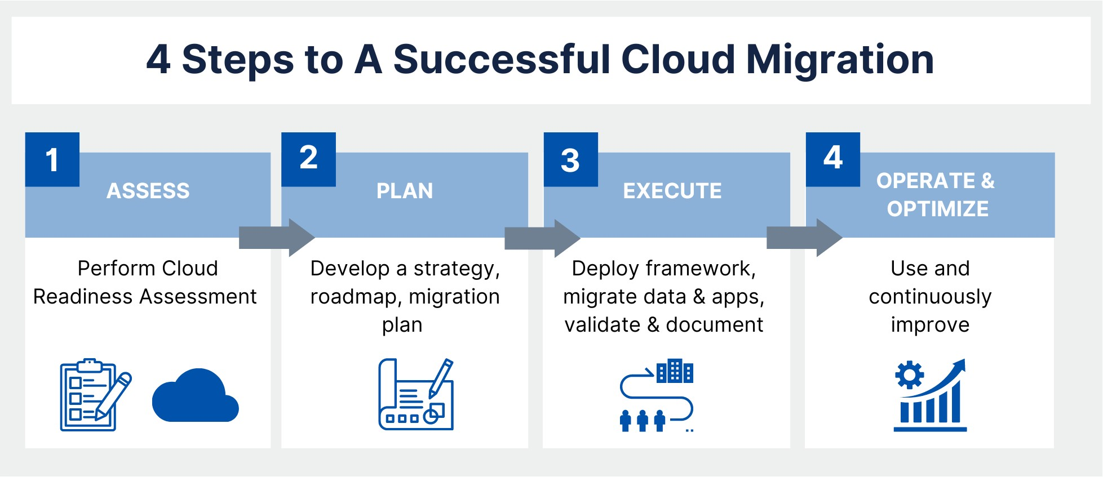

1. Change Management Framework:

Change management is critical for a smooth transition to cloud-based systems. The framework ensures that employees and stakeholders adopt the new system effectively while maintaining operational continuity. Here's an in-depth explanation:

## Structured Approaches:

### ADKAR Model

This model focuses on individual-level changes to drive organizational transformation.

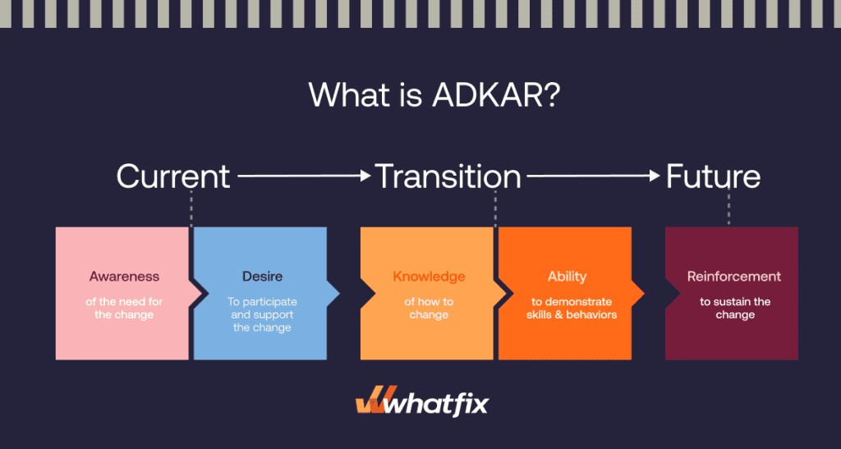

### Awareness:

Educate stakeholders (employees, managers, and clients) about the necessity of migrating to the cloud.

Highlight issues with the current system (e.g., slow response times, scalability problems) and explain how the cloud addresses them.

Use workshops, emails, and meetings to communicate benefits like flexibility, scalability, and cost savings.

### Desire:

Foster a willingness to embrace the new system by addressing employee concerns (e.g., job security, workflow changes).

Show real-life examples or case studies of companies that benefited from cloud migration.

Create incentives, such as performance bonuses or public recognition for adopting the changes.

### Knowledge:

Conduct training sessions to teach employees how to use the cloud system effectively.

Provide documentation, videos, and FAQs for self-paced learning.

Identify champions or super-users within departments to help guide peers.

### Ability:

Offer hands-on practice through sandbox environments or simulations.

Assign mentors or technical support teams to address issues during the transition phase.

Ensure that leadership demonstrates usage, encouraging others to follow suit.

### Reinforcement:

Monitor progress using adoption KPIs (e.g., percentage of employees using the system daily).

Reward successful usage with feedback, incentives, or recognition programs.

Continuously gather feedback to improve the system and address lingering issues.

### Kotter's 8-Step Change Model

This organizational-level framework emphasizes leadership and strategic execution:

### Create a Sense of Urgency:

Show stakeholders why immediate action is necessary (e.g., competition, customer dissatisfaction).

### Build a Guiding Coalition:

Form a team of influential leaders across departments to champion the migration effort.

### Develop a Strategic Vision:

Create a clear roadmap for migration, emphasizing goals like scalability and efficiency.

### Communicate the Vision:

Use all communication channels (meetings, newsletters, intranet) to share updates consistently.

### Empower Broad-Based Action:

Remove barriers (e.g., technical limitations, skill gaps) that hinder progress.

### Generate Short-Term Wins:

Highlight quick victories, like improved response times for smaller datasets.

### Sustain Acceleration:

Use early wins as momentum to push for full adoption across the organization.

### Institute Change:

Embed cloud practices into company culture by integrating them into performance reviews, processes, and training.

# Cloud Migration Plan:

A detailed migration plan ensures the transition happens smoothly and minimizes disruptions. Here’s an extended breakdown:

## Assessment Phase:

### Infrastructure Audit:

Identify all existing applications, databases, and dependencies.

Map out which components need migration (e.g., customer databases, transactional systems) and which can remain on-premises.

### Risk Identification:

Assess risks such as data loss, downtime, or compatibility issues. Develop contingency plans to address these risks.

### Stakeholder Analysis:

Identify who will be affected (e.g., IT teams, end users) and plan accordingly to minimize their disruption.

## Backup Phase:

### Data Backups:

Create multiple backups of all critical data (e.g., incremental and full backups) to ensure recovery in case of migration failure.

Use reliable backup services or tools like AWS Backup, Azure Backup, or third- party solutions.

### Testing Backup Integrity:

Run tests to verify that backups are accessible, complete, and restorable.

## Migration Phase:

### Phased Migration:

Migrate non-critical systems first (e.g., internal tools) to test processes. Gradually move critical systems, monitoring performance and user feedback.

### Parallel Migration:

Run the legacy and cloud systems simultaneously during the transition phase to ensure continuity.

Compare outputs from both systems to identify and resolve discrepancies.

### Component Testing:

Validate each migrated system or dataset to ensure functionality before moving the next batch.

## Post-Migration Monitoring:

### Performance Tracking:

Use monitoring tools (e.g., AWS CloudWatch, Google Operations Suite) to track system response times, uptime, and error rates.

Compare post-migration performance against baseline metrics from the old system.

### Issue Resolution:

Have a dedicated team to address bugs, data integrity issues, or user complaints.

## Change Rollout Plan:

### Gradual Introduction:

Introduce the cloud system in stages, department by department, to manage the workload and handle issues effectively.

### Communication and Feedback:

Regularly update stakeholders on progress and collect their feedback to improve the rollout process.

Build a report & migration plan (which includes KPIs, tests, and customer satisfaction)

**Introduction**

TechNova is currently experiencing challenges with its outdated data management systems, which are affecting scalability, performance, and security. To address these issues, Maya, a data expert, has proposed migrating to a cloud-based solution. This migration plan ensures scalability, security, and minimal disruption to operations while enhancing customer satisfaction and trust.

**Cloud Migration Plan**

**1. Assessment Phase**

* **Audit Current Infrastructure:**
  + Identify dependencies, legacy systems, and critical databases.
  + Assess compatibility of existing applications with cloud platforms.
* **Risk Analysis:**
  + Potential issues: data loss, downtime, integration challenges.
  + Develop contingency strategies for identified risks.
* **Stakeholder Analysis:**
  + Engage employees, IT teams, and customers impacted by migration.

**2. Backup Phase**

* Create multiple data backups to avoid loss during migration.
* Use tools like AWS Backup or Azure Backup.
* **Testing Backup Integrity:**
  + Validate that data can be restored successfully.

**3. Migration Phase**

* **Phased Migration:**
  + Start with non-critical systems to test processes, followed by mission-critical systems.
* **Parallel Operations:**
  + Maintain legacy and cloud systems concurrently for smooth transition.
* **Testing:**
  + Validate system functionality, response times, and data integrity for each migration batch.

**4. Post-Migration Monitoring**

* **Performance Tracking:**
  + Tools: AWS CloudWatch, Azure Monitor.
  + Monitor KPIs such as response time, uptime, and error rates.
* **Issue Resolution:**
  + Assign a dedicated team for quick resolution of bugs and complaints.

**KPIs for Measuring Success**

1. **System Performance:**
   * Target 99.9% uptime.
   * Reduce response times by at least 30%.
2. **Scalability:**
   * Ability to handle 50% more concurrent users within 6 months.
3. **Customer Satisfaction:**
   * Achieve an 85% satisfaction score in post-migration surveys.
4. **Operational Continuity:**
   * Ensure less than 5 hours of downtime during migration.

**Testing Strategy**

1. **Performance Tests:**
   * Measure pre- and post-migration response times.
   * Load testing to evaluate scalability under increased demand.
2. **Data Integrity Tests:**
   * Verify all migrated data is accurate and accessible.
3. **System Functionality Tests:**
   * Confirm all applications work seamlessly in the cloud environment.

**Customer Satisfaction Plan**

* **Communication:**
  + Regular updates on migration progress.
  + Dedicated support channels for customer queries.
* **Feedback Collection:**
  + Conduct surveys post-migration to gather user feedback.
* **Training:**
  + Provide tutorials and FAQs to help users adapt to new systems.

**Comparative Analysis of Cloud Models**

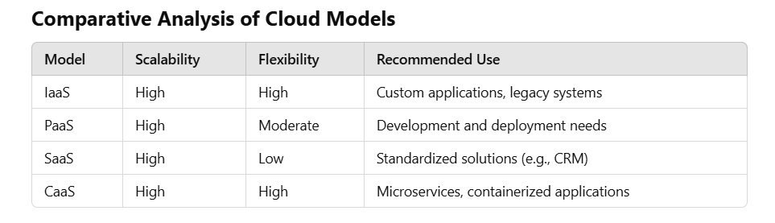

TechNova's needs align best with a **hybrid cloud approach** combining IaaS and PaaS for flexibility and scalability.

**Selected Cloud Provider**

**AWS** is recommended for:

* High scalability and availability.
* Advanced encryption and security tools.
* Competitive pay-as-you-go pricing.
* Extensive global infrastructure and support.

**Change Management Framework**

1. **Awareness:**
   * Educate stakeholders on the benefits of migration.
   * Address concerns with workshops and communication.
2. **Training:**
   * Provide hands-on practice with sandbox environments.
   * Offer continuous support via mentors and technical experts.
3. **Reinforcement:**
   * Track adoption rates and provide rewards for milestones achieved.

**Timeline**

| **Phase** | **Duration** | **Key Deliverables** |
| --- | --- | --- |
| Assessment | 4 weeks | Infrastructure audit, risk analysis |
| Backup and Preparation | 2 weeks | Verified data backups |
| Migration | 8 weeks | Phased transition, testing, validation |
| Post-Migration | Ongoing (6 months) | Performance tracking, issue resolution |

**Conclusion**

Migrating to the cloud will enable TechNova to address its scalability, performance, and security challenges while minimizing operational disruptions. A structured migration plan, clear KPIs, and a focus on customer satisfaction will ensure success.